**ST.XAVIER’S COLLEGE**

MAITIGHAR, KATHMANDU



**Computer Graphics**

Assignment #8

Submitted By:

Dibash Poudel

013BSCCSIT017

2nd year/ 4th semester

Submitted to:

Er. Anil Shah

Lecturer

Department of Computer Science

**Statement:**

Perform transformation in the image by reflection.

1. **REFLECTION:**

**Algorithm:**

1. Get the width and height of the source image
2. Get parameter for reflection axis (1 for x-axis, 2 for y-axis)
3. For each point i in width

For each point j in height

If parameter==1

The translated point (x’, y’) is given by

x' = i

y’ = - j

If parameter==2

The translated point (x’, y’) is given by

x' = - i

y’ = j

Plot the points (x’, y’) with the same color as source in destination

1. Stop

(General concept for display screens: origin is in top left of the screen and y-axis is positive downwards and hence there is no negative coordinates)

**Source Code:**

**//---------------------------------------------------------------------------**

**#include <vcl\vcl.h>**

**#pragma hdrstop**

**#include "refl.h"**

**//---------------------------------------------------------------------------**

**#pragma resource "*.dfm"**

**TForm1 *Form1;**

**//---------------------------------------------------------------------------**

**__fastcall TForm1::TForm1(TComponent* Owner)**

**: TForm(Owner)**

**{**

**}**

**//---------------------------------------------------------------------------**

**void __fastcall TForm1::reflectXClick(TObject *Sender)**

**{**

**int h,w,i,j,a,b,c,d;**

**int mx,my;**

**h=outPanel->Height;**

**w=outPanel->Width;**

**mx=w/2;**

**my=h/2;**

**for(i=0;i<=w;i++){**

**for(j=0;j<=h;j++){**

**a = -(i-mx)+mx;**

**b = j;**

**outPanel->Canvas->Pixels[a][b] = outPanel->Canvas->Pixels[i][j];**

**}**

**}**

**}**

**//---------------------------------------------------------------------------**

**void __fastcall TForm1::reflectYClick(TObject *Sender)**

**{**

**int h,w,i,j,a,b,c,d;**

**int mx,my;**

**h=outPanel->Height;**

**w=outPanel->Width;**

**mx=w/2;**

**my=h/2;**

**for(i=0;i<=w;i++){**

**for(j=0;j<=h;j++){**

**a = i;**

**b = -(j-my)+my;**

**outPanel->Canvas->Pixels[a][b] = outPanel->Canvas->Pixels[i][j];**

**}**

**}**

**}**

**//------------------------**

**Output:**

**1st Display**

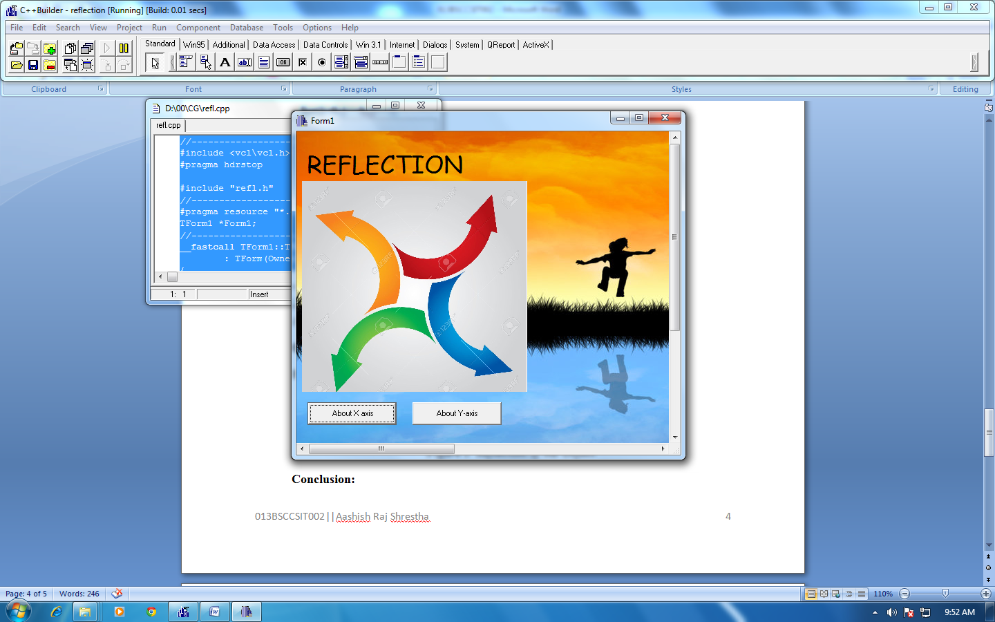

**About X-axis**

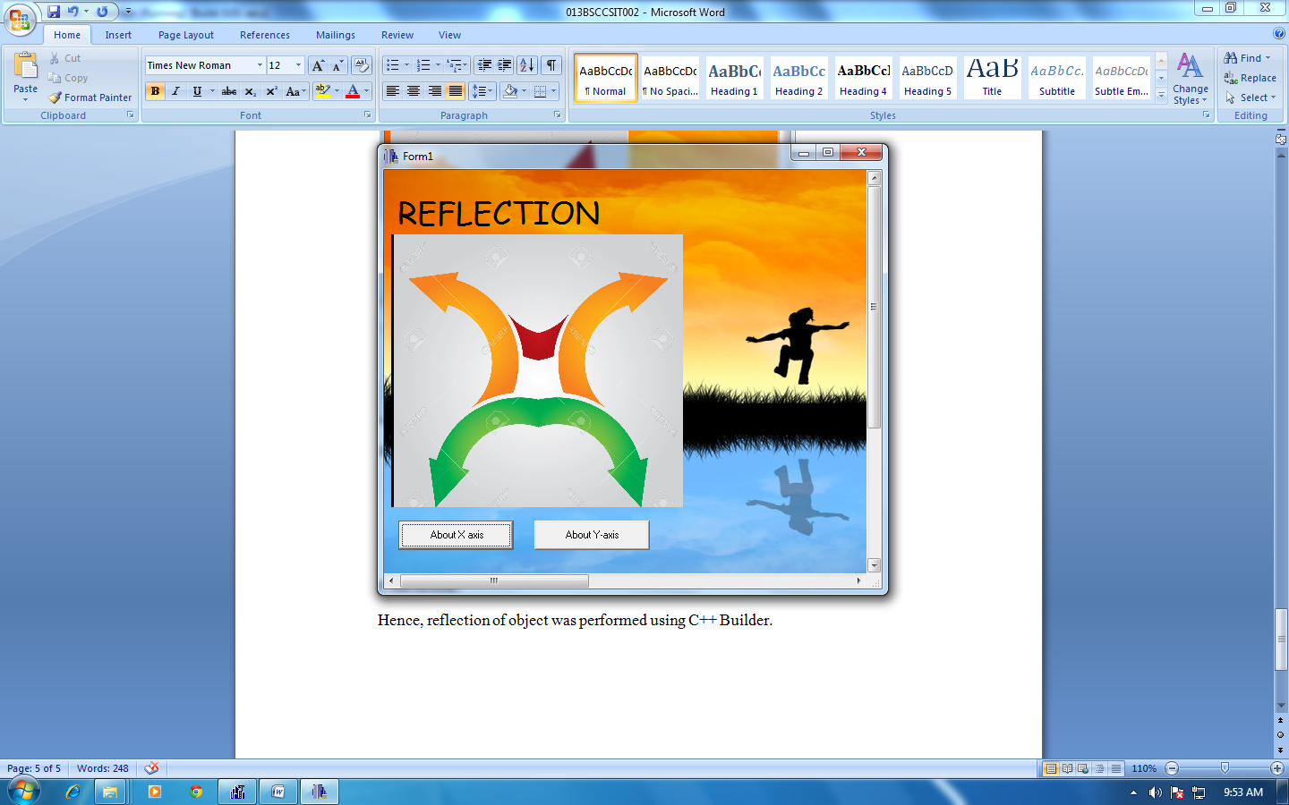

**About Y-axis**

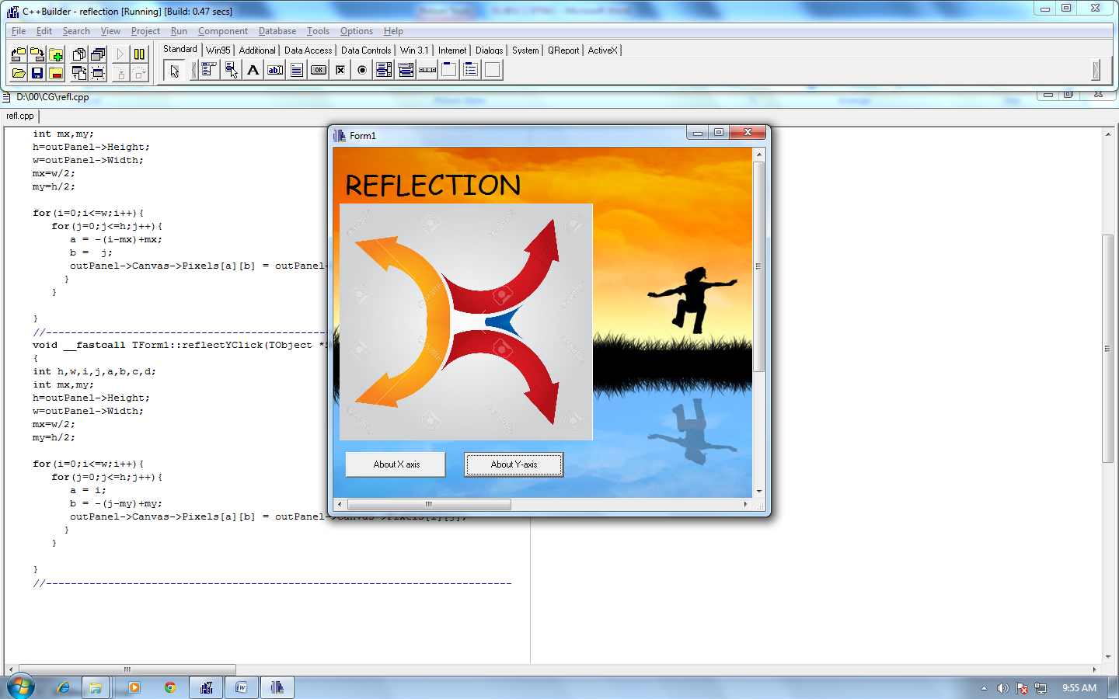

**Conclusion:**

Hence, reflection of object was performed using C++ Builder.